Samarqand viloyati kasbiy ko’nikmalar mintaqaviy markazining
2025 yil “26” avgustdagi, ________-sonli buyrug’iga
II-ilova

Metallarga ishlov berish mexanigi (mashinasozlik texnologiyasi) kasbi 1+2 loyihasi doirasidagi 2-oqim talabalari uchun Ya DAK imtihonlari uchun namunaviy nazariy va amaliy topshiriq savollari
- Tokarniy mashinasi bilan diametri 20 quvurga 15 mm rezba oching.
- Tokarniy mashinasi bilan diametri 50 quvurga 30 gradus faska oching.
- Tokarniy mashinasi bilan diametri 20 quvurga 2 mm faska oching.
- Tokarniy mashinasi bilan diametri 50 turbani 15 mm kesib oling.
- Tokarniy mashinasi bilan diametric 20 prutokga markaz belgilang.
- Tokarniy mashinasi bilan diametri 40 prutokga 20 mm parmalang.
- Tokarniy mashinasi bilan diametri 35 prutokga 20mm ichki rezba oching.
- Tokarniy mashinasi bilan diametri 38 prutokga 15 mm masofaga 2 mm paz oching.
- Tokarniy mashinasi bilan diametri 40 prutokga ichki diamaetri 15 mm yo’ning.
- Tokarniy mashinasi bilan diametri 40 prutokga 45 gradus ishlov bering.
- Tokarniy mashinasi bilan diametri 35 prutokga 20 mm automatik ishlov bering.
- Tokarniy mashinasi bilan diametri 10 pturokga 5 mm rezba oching.
- Tokarniy mashinasi bilan diametri 20 prutokka ichki rezba oching.
- Tokarniy mashinasining yog’lash tizimini tekshiring.
- Tokarniy mashinasining knematik sxemasini tushuntirib bering.
- Frezerniy mashinasining knematik sxemasini tushuntirib bering.
- Frezerniy mashinasi bilan 20mm listni ustki yuzasini 2 mm ishlov bering.
- Frezerniy mashinasi bilan 40mm plastinaga 15 mm fasofadan 20 mm paz oching.
- Frezerniy mashinasi bilan metal plastinaga 15 mm parmalang.
- Frezerniy mashinasi bilan 4 ta teshik xosil qilib zenkofkalang.
- Frezerniy mashinasi bilan 15 mm ichki rezba oching.
- Frezerniy mashinasi bilan aylana yuzalarga ishlov bering.
- Frezerniy mashinasi bilan vertikal yuzaga ishlov berib ko’rsating.
- Frezerniy mashinasi bilan garizantal yuzaga ishlov berib ko’rsating.
- Frezerniy mashinasi o’qlarini tushuntirib bering.
- Frezerniy mashinasi z o’qi boylab 15 mm tushuring.
- Frezerniy mashinasini tezliklarni rostlashni ko’rsating.
- Frezerniy mashinasi bilan sentr belgilang.
- Frezerniy mashinasining turlari xaqida malumot bering.
- Frezerniy mashinasi bilan qanday detallarga ishlov berib bo’lmaydi.

Izoh: Asosiy amaliy topshiriqlar, variantlar asosida keying betlarda ilova qilingan.

Asosiy amaliy topshiriqlar to’plami
Variant-1
1 | 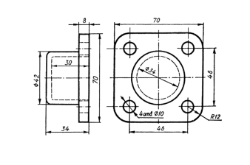 | Chizmani o'qing va tushuntirib bering
2 | 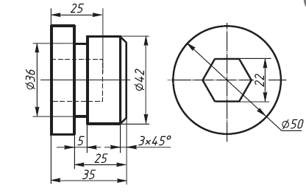 | Chizmani SolidWorks dasturida chizib, G-M kod yoki Solid CAM dasturida programma tuzing
3 | 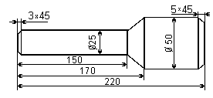 | Detalni CNCpro dasturida yasang

Variant-2
1 | 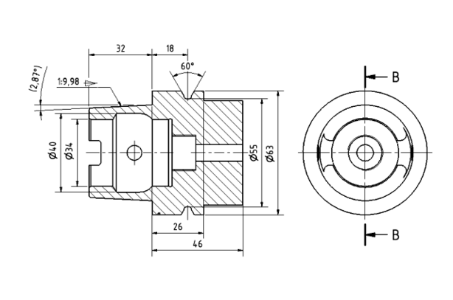 | Chizmani o'qing va tushuntirib bering
2 | 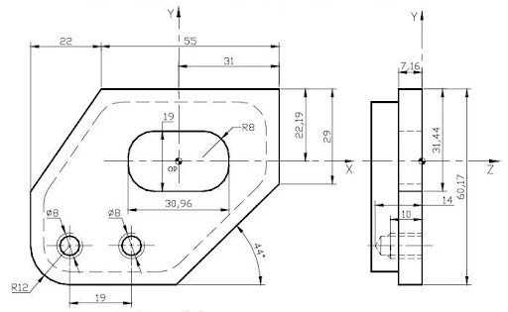 | Chizmani SolidWorks dasturida chizib, G-M kod yoki Solid CAM dasturida programma tuzing
3 | 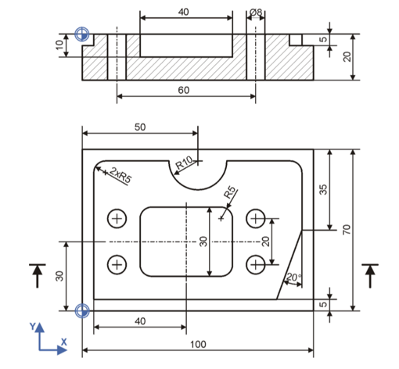 | Detalni CNCpro dasturida yasang

Variant-3
1 | 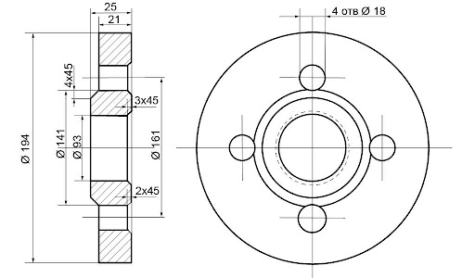 | Chizmani o'qing va tushuntirib bering
2 | 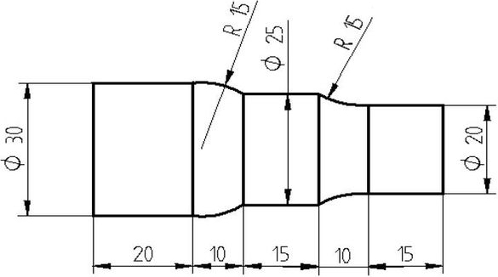 | Chizmani SolidWorks dasturida chizib, G-M kod yoki Solid CAM dasturida programma tuzing
3 | 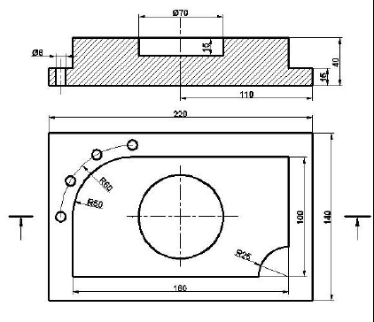 | Detalni CNCpro dasturida yasang

Variant-4
1 | 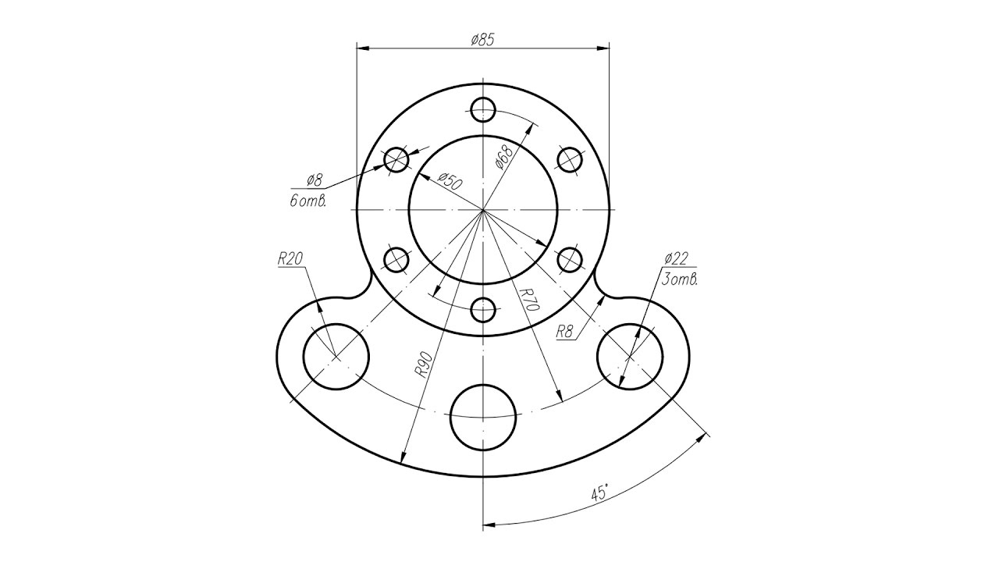 | Chizmani o'qing va tushuntirib bering
2 | 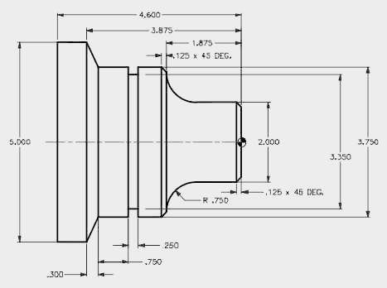 | Chizmani SolidWorks dasturida chizib, G-M kod yoki Solid CAM dasturida programma tuzing
3 | 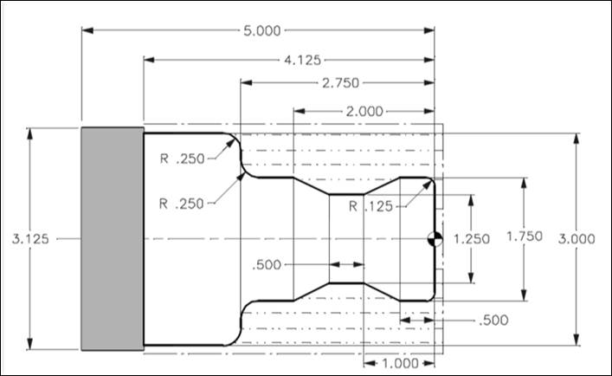 | Detalni Tokarlik CNCpro dasturida yasang

Variant-5
1 | 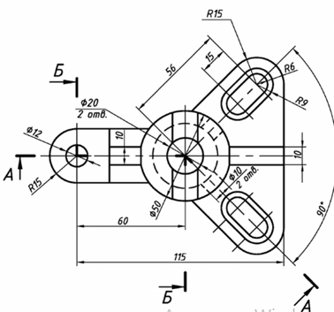 | Chizmani o'qing va tushuntirib bering
2 | 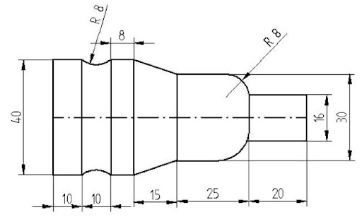 | Chizmani SolidWorks dasturida chizib, G-M kod yoki Solid CAM dasturida programma tuzing
3 | 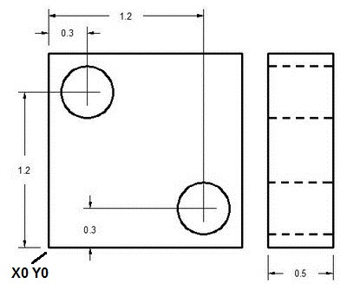 | Detalni CNCpro dasturida yasang

Variant-6
1 | 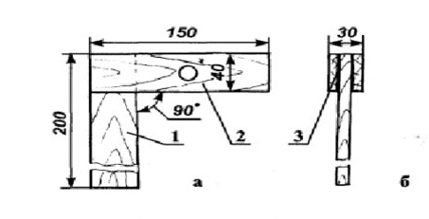 | Chizmani o'qing va tushuntirib bering
2 | 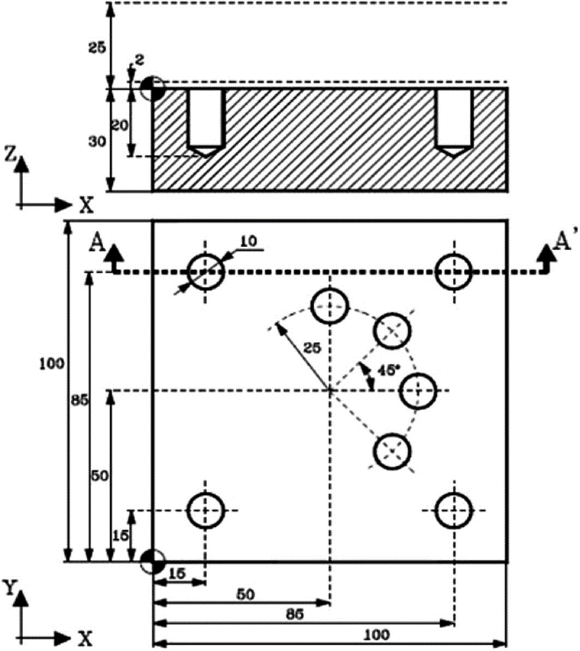 | Chizmani SolidWorks dasturida chizib, G-M kod yoki Solid CAM dasturida programma tuzing
3 | 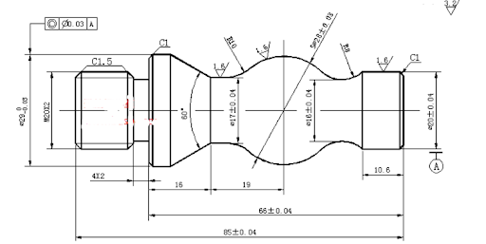 | Detalni CNCpro dasturida yasang

Variant-7
1 | 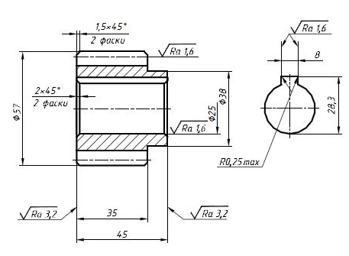 | Chizmani o'qing va tushuntirib bering
2 | 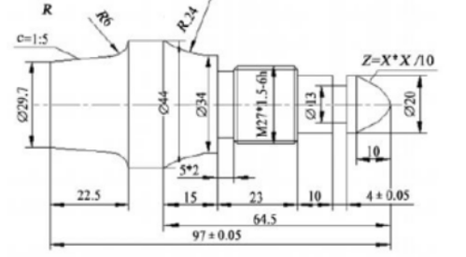 | Chizmani SolidWorks dasturida chizib, G-M kod yoki Solid CAM dasturida programma tuzing
3 | 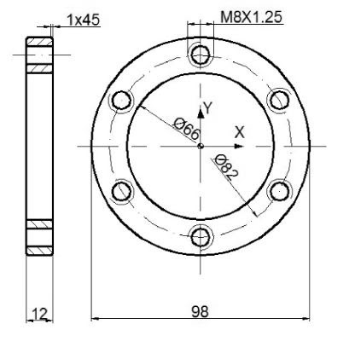 | Detalni CNCpro dasturida yasang

Variant-8
1 | 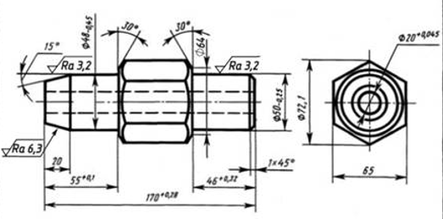 | Chizmani o'qing va tushuntirib bering
2 | 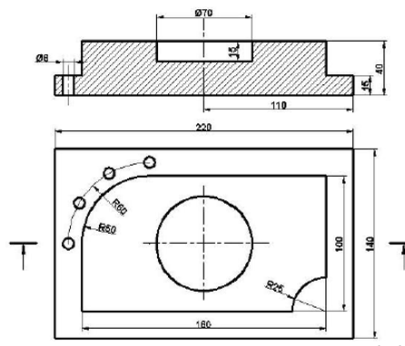 | Chizmani SolidWorks dasturida chizib, G-M kod yoki Solid CAM dasturida programma tuzing
3 | 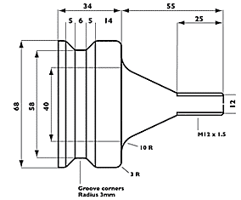 | Detalni CNCpro dasturida yasang

Variant-9
1 | 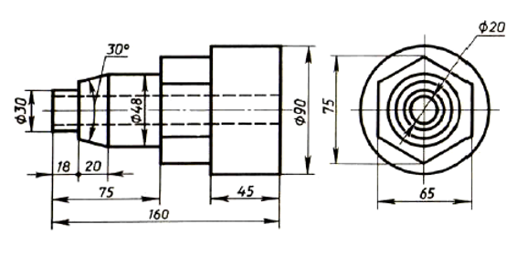 | Chizmani o'qing va tushuntirib bering
2 | 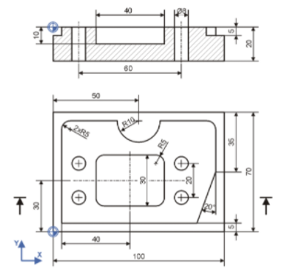 | Chizmani SolidWorks dasturida chizib, G-M kod yoki Solid CAM dasturida programma tuzing
3 | 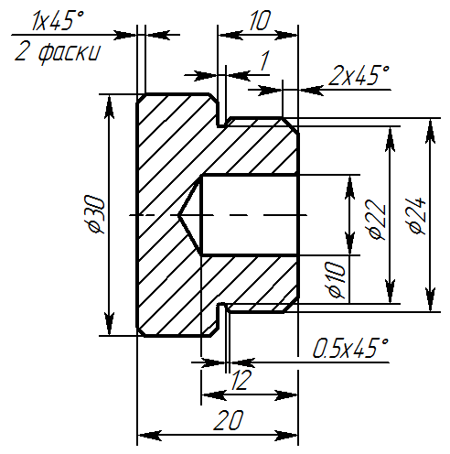 | Detalni CNCpro dasturida yasang

Variant-10
1 | 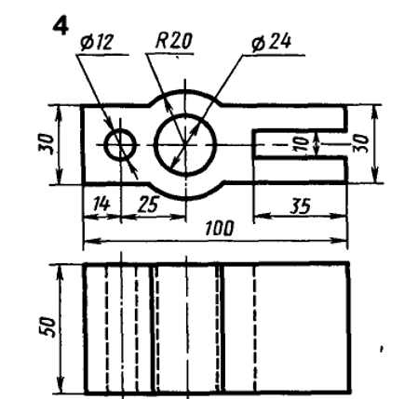 | Chizmani o'qing va tushuntirib bering
2 | 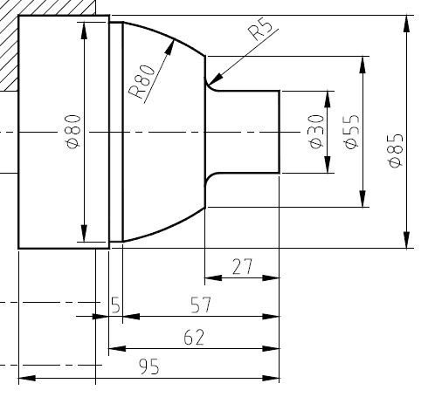 | Chizmani SolidWorks dasturida chizib, G-M kod yoki Solid CAM dasturida programma tuzing
3 | 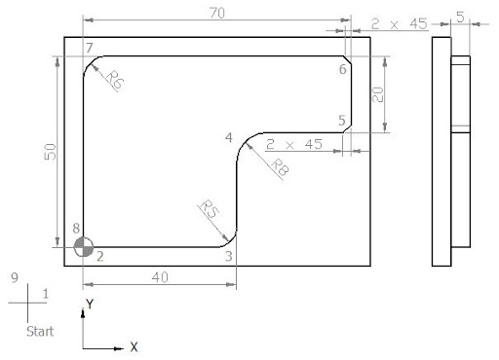 | Detalni CNCpro dasturida yasang

Variant-11
1 | 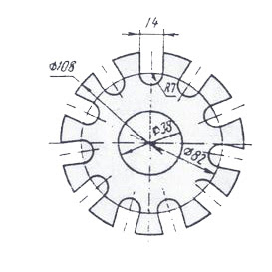 | Chizmani o'qing va tushuntirib bering
2 | 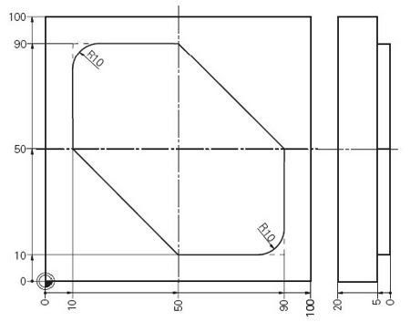 | Chizmani SolidWorks dasturida chizib, G-M kod yoki Solid CAM dasturida programma tuzing
3 | 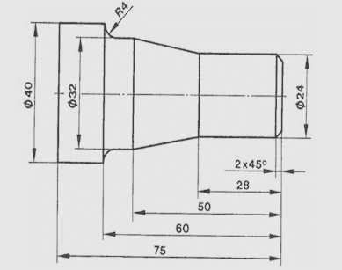 | Detalni CNCpro dasturida yasang

Variant-12
1 |  | Chizmani o'qing va tushuntirib bering
2 |  | Chizmani SolidWorks dasturida chizib, G-M kod yoki Solid CAM dasturida programma tuzing
3 | 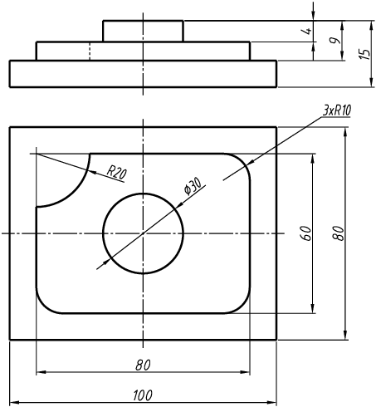 | Detalni CNCpro dasturida yasang

Variant-13
1 | 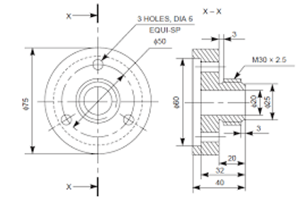 | Chizmani o'qing va tushuntirib bering
2 | 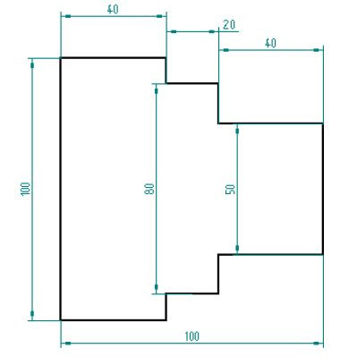 | Chizmani SolidWorks dasturida chizib, G-M kod yoki Solid CAM dasturida programma tuzing
3 | 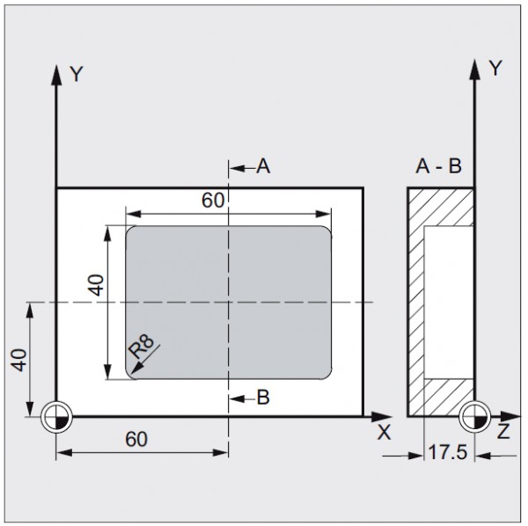 | Detalni CNCpro dasturida yasang

Variant-14
1 | 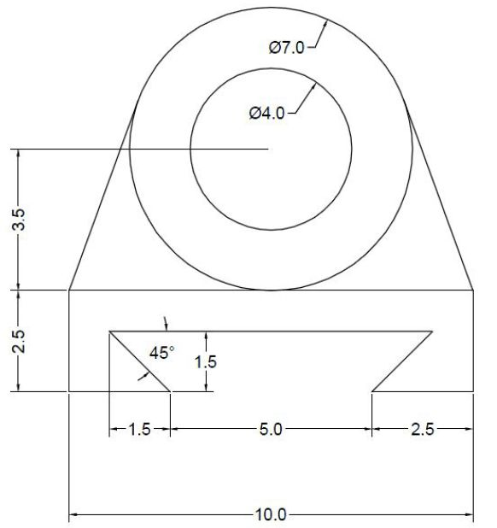 | Chizmani o'qing va tushuntirib bering
2 | 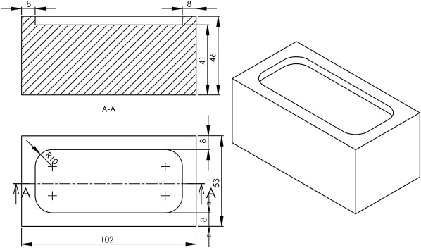 | Chizmani SolidWorks dasturida chizib, G-M kod yoki Solid CAM dasturida programma tuzing
3 | 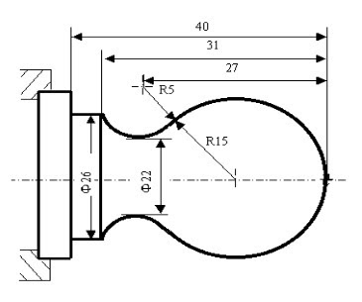 | Detalni CNCpro dasturida yasang

Variant-15
1 | 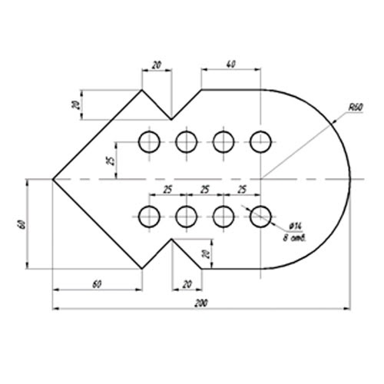 | Chizmani o'qing va tushuntirib bering
2 | 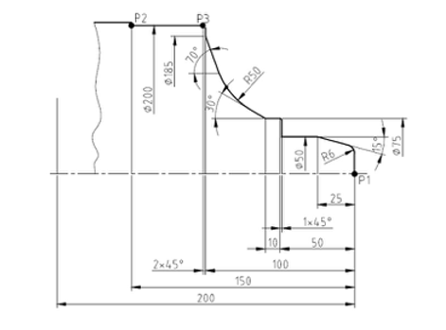 | Chizmani SolidWorks dasturida chizib, G-M kod yoki Solid CAM dasturida programma tuzing
3 |  | Detalni CNCpro dasturida yasang

Variant-16
1 | 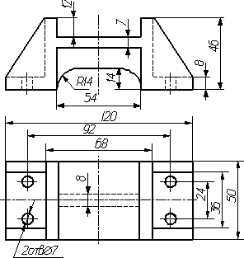 | Chizmani o'qing va tushuntirib bering
2 | 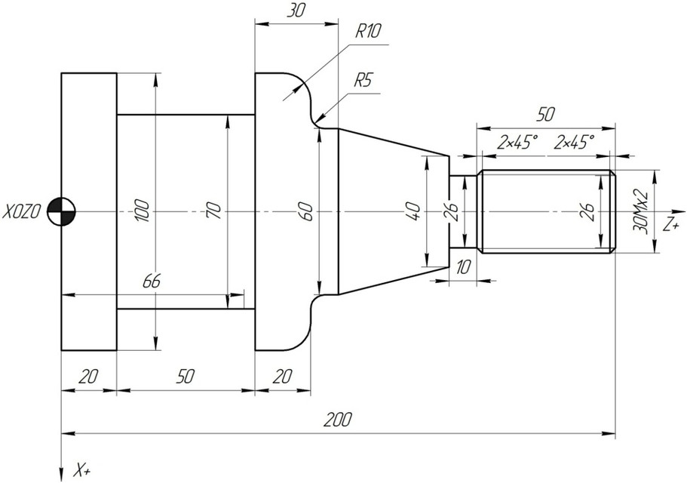 | Chizmani SolidWorks dasturida chizib, G-M kod yoki Solid CAM dasturida programma tuzing
3 | 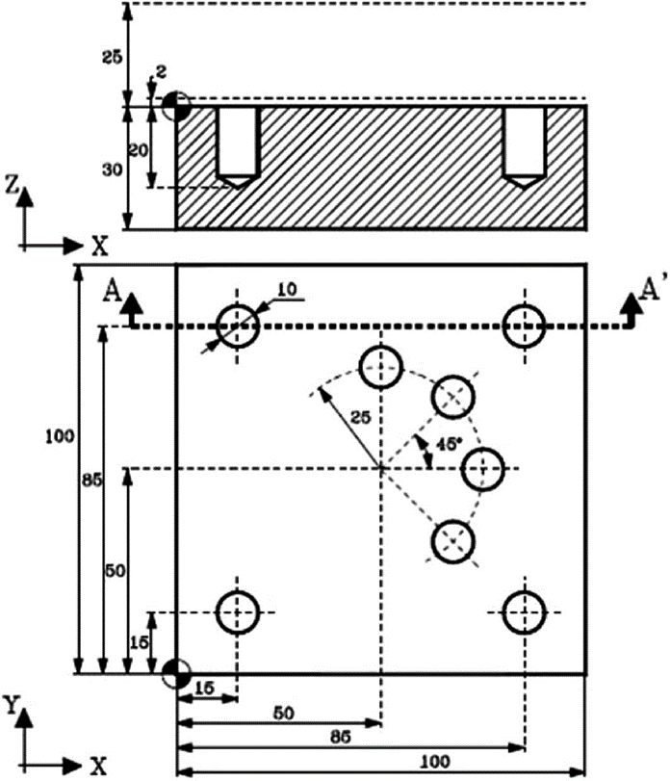 | Detalni CNCpro dasturida yasang

Variant-17
1 | 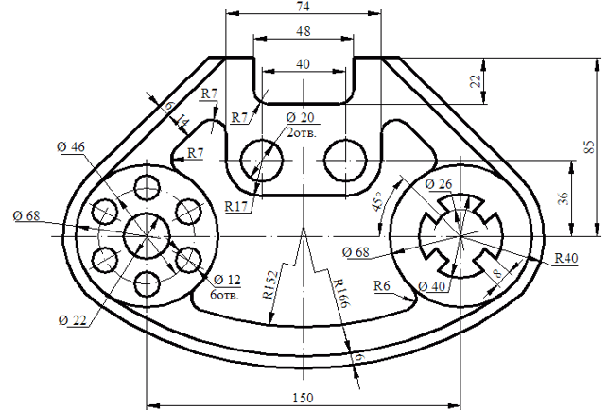 | Chizmani o'qing va tushuntirib bering
2 | 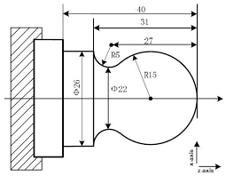 | Chizmani SolidWorks dasturida chizib, G-M kod yoki Solid CAM dasturida programma tuzing
3 |  | Detalni CNCpro dasturida yasang

Variant-18
1 | 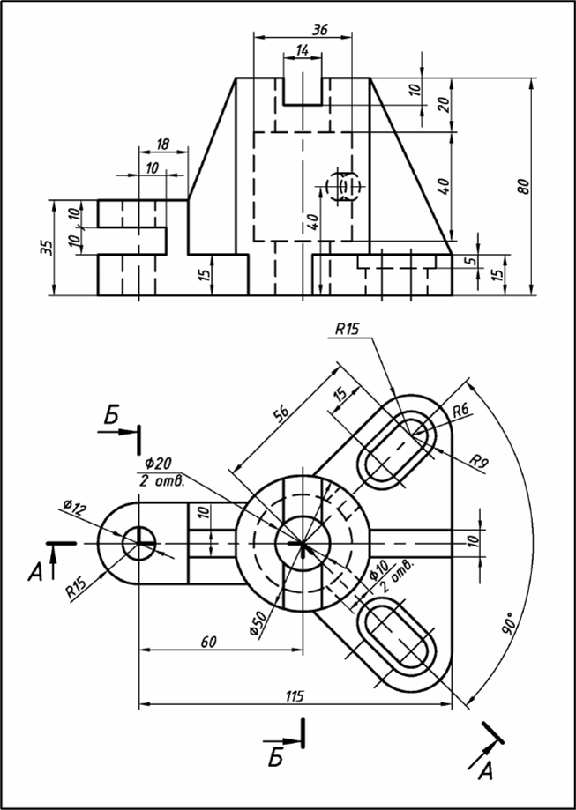 | Chizmani o'qing va tushuntirib bering
2 | 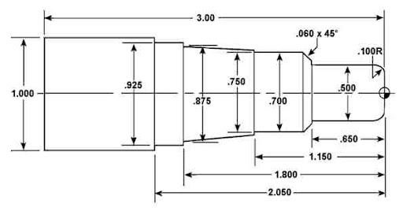 | Chizmani SolidWorks dasturida chizib, G-M kod yoki Solid CAM dasturida programma tuzing
3 | 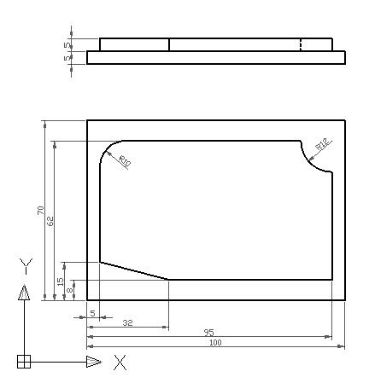 | Detalni CNCpro dasturida yasang

Variant-19
1 | 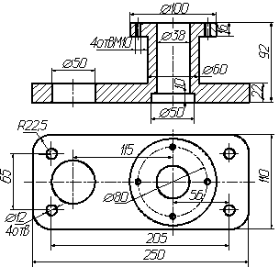 | Chizmani o'qing va tushuntirib bering
2 | 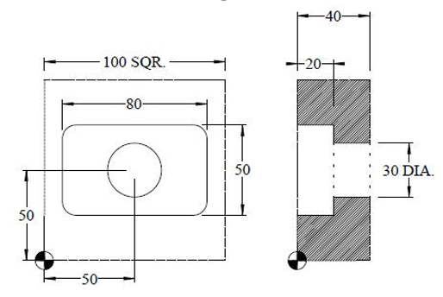 | Chizmani SolidWorks dasturida chizib, G-M kod yoki Solid CAM dasturida programma tuzing
3 | 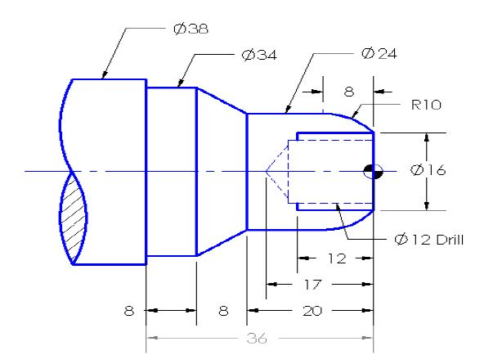 | Detalni CNCpro dasturida yasang

Variant-20
1 | 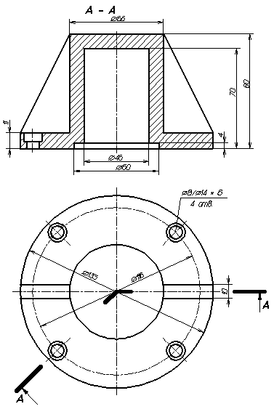 | Chizmani o'qing va tushuntirib bering
2 |  | Chizmani SolidWorks dasturida chizib, G-M kod yoki Solid CAM dasturida programma tuzing
3 | 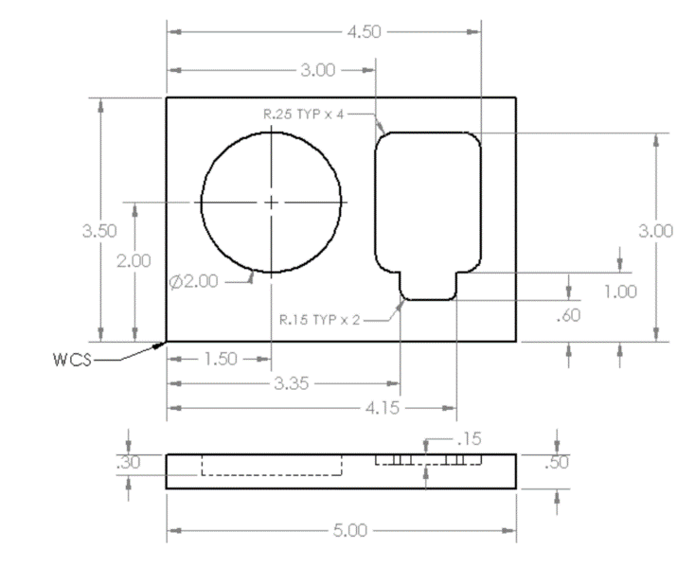 | Detalni CNCpro dasturida yasang

Tuzuvchi:
Mashinasozlik va elektronika
bo’limi boshlig’i R.Xo’jamatov

